Down Shift Telltale – CGEA1.3

Functional Description

The purpose of the Down Shift Telltale is to inform the driver that a gear shift needs to be made for fuel efficient operation of a manual transmission powertrain.

The Down_Shift_Telltale correlates the TrnManShif_D_IndDrv signal and the Operational_Mode to illuminate or extinguish the Down Shift_Telltale.

The Down Shift Telltale shall provide an iconic representation that will illuminate or extinguish to inform the driver of a posibility that the Down Shift indicator is on.

Interfaces

Interface Context Diagram (I/O Block Diagram)
- 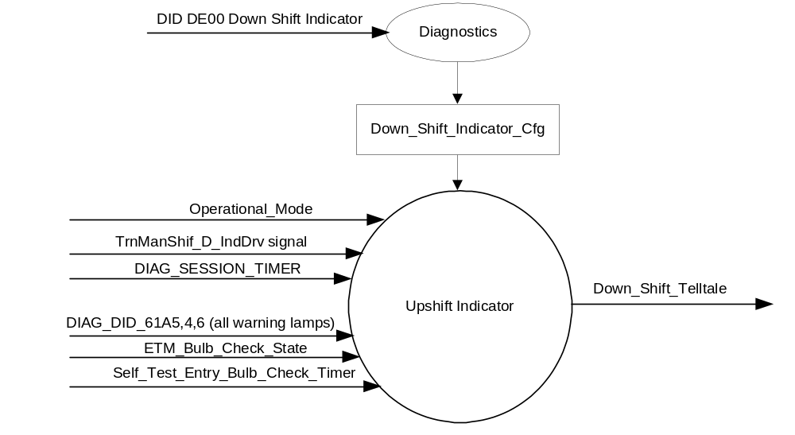Down Shift Indication

Inputs

      - INTERNAL:
            - DIAG_SESSION_TIMER
            - Operational_Mode
            - DIAG_DID_61A5,4,6 (all warning lamps)
            - ETM_Bulb_Check_State
            - Self_Test_Entry_Bulb_Check_Timer
            - Down_Shift_Indicator_Cfg
      - MUX message on the CAN Bus

- TrnManShif_D_IndDrv Signal
Signal Name | Size  (bits) | Detail | Units | Res | Offset | State Encoded | Min. | Max.
TrnManShif_D_IndDrv | 3 |  |  | 1 | 0 |  | 0 (0x0) | 7 (0x7)
 |  | No_indication |  |  |  | 0x0
 |  | Upshift_Fuel_Economy _recommendation |  |  |  | 0x1
 |  | Upshift_Performance_  recommendation |  |  |  | 0x2
 |  | Upshift_warning (fuel cut imminent and reaching rev limit) |  |  |  | 0x3
 |  | Downshift_recommendation |  |  |  | 0x4
 |  | Undefined |  |  |  | 0x5
 |  | Undefined |  |  |  | 0x6
 |  | Undefined |  |  |  | 0x7

Outputs
Down_Shift_Telltale, which is used to control the state of the LED

Function/Performance

Operational Modes

Mode | Differentiating Vehicle Conditions
Sleep Mode | Down ShiftTelltale OFF
Limited Mode | Down ShiftTelltale OFF
Normal Mode | Down ShiftTelltale ON/OFF
Crank Mode | Down ShiftTelltale ON/OFF

Voltage Levels

Refer to the Cluster Features table located in the Operational Modes and Voltage Range Strategies Section in this SPSS

Human-Machine Interface

Visual

Indicator Graphics / Display Format


For actual symbol definition refer to database of the 03-0685 ARL requirement

Indicator Color Coordinates

Green - Reference SDS IL-0017

Indicator Characteristics

LED - Down Shift Telltale

Audio

None.

System Accuracy

The Down_Shift_Telltale shall change the state of the Telltale within 100msec of a state change as indicated in the state matrix reference 1.3.5.1 Subsystem Algorithm Flowchart/ State Diagram

Operation: Performance and Functional

Subsystem Algorithm Flowchart / State Diagram

- State Matrix for Down Shift Telltale
Operational_  Mode | Down_Shift_  Indicator_Cfg | ETM Bulb_ Check_State | DIAG_SESSION_  TIMER | Self_Test_ Entry_Bulb_ Check_Timer | DIAG_DID_  61A5, 4,6  (all warning lamps) | TrnManShif_D  _IndDrv Signal | Down_Shift_  Telltale
Normal or Crank | Enabled | X | Not Active | X | X | Downshift_  recommendation (0x4) | ON
Normal or Crank | Enabled | ON (0x1) | Not Active | X | X | X | ON
Normal | Enabled | OFF (0x0) | Not Active | X | X | Missing as per 1.4.1 | OFF
Normal | Enabled | X | Active | Not Active | Not Received | Downshift_  recommendation (0x4) | ON
Normal | Enabled | ON (0x1) | Active | Not Active | Not Received | X | ON
Normal | Enabled | X | Active | X | X | X | ON
Normal | Enabled | X | Active | X | ON (0x1) | X | ON
Normal | Enabled | X | Active | Active | X | X | ON
All Other Cases |  |  |  |  |  |  | OFF
X=Don’t Care
Not Received = The state when a DIAG_SESSION_TIMER is active and the DID has not been received

Operation Description (supports algorithm flowchart /state diagram)

- Down_Shift_Telltale shall default to OFF when transitioning from Sleep or Limited to Crank or Normal until commanded by the TrnManShif_D_IndDrv Signal.

Function Safety Classification (EMC)

B

Memory Storage
Parameter Name |  | Description |  | Value at  Battery Connect |  | Value at  Module Wake-up
Down_Shift_Telltale |  | Used to control the state of the LED |  | OFF (0x0) |  | OFF (0x0)
Down_Shift_Indicator_Cfg |  | Encoded indicator of feature presence controlled via CAN at EOL at VO plant. |  | Use Stored Value |  | Use Stored Value
TrnManShif_D_IndDrv Signal |  | CAN Signal sent from the PCM |  | No_Indication (0x0) |  | Do Not Init
DIAG_DID_61A5,4,6 (all warning lamps) |  | Warning Lamp status 2, byte 4, bit 6 (all warning lamps) |  | 0 (0x0) |  | 0 (0x0)
ETM_Bulb_Check_State |  | State indictator for warning bulb in ETM |  | OFF (0x0) |  | OFF (0x0)
Operational_Mode |  | 4 state indicator for cluster operational mode |  | Limited |  | Limited, Normal or Crank
DIAG_SESSION_TIMER | Timer used to time-out a diagnostic session |  | Not Active |  | Not Active
Self_Test_Entry_Bulb_Check_ Timer | Timer used in diagnostic session to do a self check of telltales |  | Not Active |  | Not Active

Prove Out

No

Reconfigurable Telltale

No

Message Center Msg

None

Error Handling

Missing Message Strategy

The signals will be declared missing as per the Diagnostics section of this SPSS.

DTCs states and history will be determined as per the Diagnostics section of this SPSS.

If the Down_Shift_Indicator_Cfg is set to Disabled, the cluster shall never log a missing message DTC due to this feature.

Diagnostics

Self Test

Bulb illuminated during self test as per Self_Entry_Bulb_Check_Timer

Engineering Test Mode

Reference section “Dealer / Engineering Test Mode (ETM)”.

Part II Performance

Supported Diagnostic PIDs (Service $22 and $2F)
Number | PID / CommonID Name | PID Type
61A5 | Warning Lamp status 2, byte 4, bit 6 (all warning lamps) | Bit Mapped

Supported Diagnostic Trouble Codes (DTCs)
DTC | Description
C10000 | Lost communication with ECM/PCM

DID DE00:
Block  Num | Block Description | Byte(s) | Bits | State: Description | "0" | "1" | Default | Comments/ Information
PACKETED BLOCKS
$00 | Option Content (B&A) | * | * | Down Shift Indicator | Disabled | Enabled | 0 (Disabled)
 | *Byte and bit location to be identified in Part II Specification for this cluster

Reference Specification

IS-0001 WARNINGS/INDICATORS/DISPLAYS PROVEOUT
IS-0046 INSTRUMENTATION MATERIAL RESISTANCE TO CLEANING
IS-0052 OPERATING VOLTAGES - FUNCTIONAL/PERFORMANCE
IS-0069 FUNCTIONAL IMPORTANCE CLASS
IS-0324 WINDSHIELD & OTHER REFLECTIONS
IS-0327 WARNING INDICATOR EVALUATION
IS-0329 FLICKERING OF LAMPS
IS-0379 NORTH AMERICAN WARNINGS AND INDICATORS STRATEGY

IL-0017 TELLTALE AND INTERIOR ILLUMINATION COLOR
IL-0021 CRAFTSMANSHIP - DISPLAYS
IL-0023 CLARITY/LEGIBILITY/READABILITY
IL-0025 INTERIOR ILLUMINATION INTENSITY
IL -0027 VISUAL CONTRAST
IL -0043 OPERATIONAL ENVIRONMENT FUNCTIONALITY
IL -0045 COLOR
IL -0047 TELLTALE; INDICATOR AND DISPLAY LIGHT INTENSITY
IL -0048 ILLUMINATION ACCEPTABILITY

03-0661 PLACEMENT: CONTROL AND DISPLAY LOCATIONS
03-0662 PLACEMENT: LOGICAL GROUPING FUNCTION AND USAGE
03-0664 PLACEMENT: DOWN VISION TO COMPONENTS WITH HIGH VISUAL DEMAND
03-0665 PLACEMENT: EXPECTED LOCATIONS OF CONTROLS AND DISPLAYS VDS
03-0670 INTERIOR VISIBILITY
03-0671 INTERIOR VISIBILITY: REFLECTIONS FROM COMPONENTS & SURFACES
03-0672 INTERIOR VISIBILITY: REFLECTIONS IN DISPLAYS
03-0673 INTERIOR VISIBILITY: VISUAL OBSCURATIONS
03-0674 INTERIOR VISIBILITY: ILLUMINATION CONTROLS / DISPLAYS
03-0675 INTERIOR VISIBILITY: VEILING GLARE
03-0677 INTERIOR VISIBILITY: SUNLIGHT WASHOUT
03-0681 IDENTIFICATION: CHARACTER AND SYMBOL SIZE
03-0682 IDENTIFICATION: LEGIBILITY
03-0685 IDENTIFICATION: SYMBOLS, ABBREV FOR CONTROL
03-0721 LOGIC OF OPERATION: OPERATIONAL STEREOTYPES
03-0722 LOGIC OF OPERATION: INTERPRETATION
03-0723 LOGIC OF OPERATION: USE OF SYSTEMS WITH VISUAL DISPLAYS

Revision History

SPSS Module Revision History

Revision Level | Name | Change Description | Date
1.0 | jgregoir | Initial Release | 6/17/2014

